SG-ZCM8052NDK-O
- 8Megapixel 52x Long Range Zoom Starlight NDAA Network and Digital Dual Output Camera Module
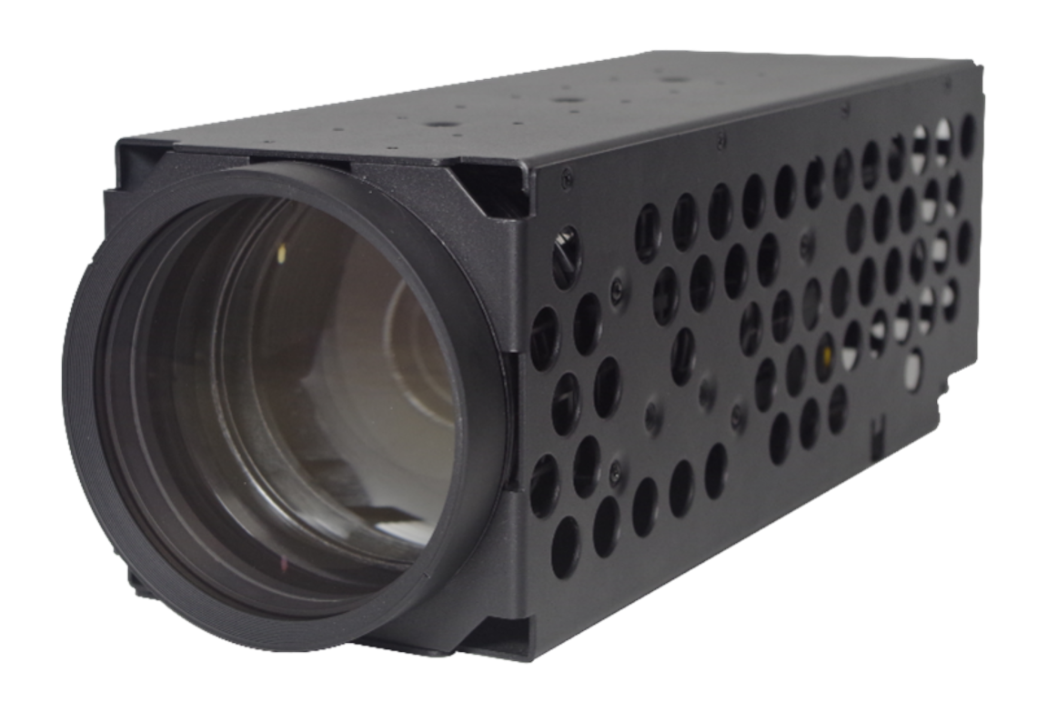
1. Features
> 1/1.8” Sony Exmor CMOS Sensor.
> Powerful 52x optical zoom (15-775mm).
> Max. 8Mp(3840x2160) Resolution
> Support various IVS functions
> Support EIS and Optical Defog
> Support LVDS digital video output synchronously
> With NOVATEK high performance chip
2. Specification
Model |  | SG-ZCM8052NDK-O
Sensor | Image Sensor | 1/1.8” Sony Starvis progressive scan CMOS
 | Effective Pixels | Approx. 8.41 Megapixel
Lens | Focal Length | 15mm~775mm, 52x Optical Zoom
 | Aperture | F2.8~F8.2
 | Field of View | H: 28.7°~0.6°, V: 16.3°~0.3°, D: 32.7°~0.7°
 | Close Focus Distance | 1m~10m (Wide~Tele)
 | Zoom Speed | Approx. 7s (Optical Wide~Tele)
 | DORI Distance  (Human) | Detect | Observe | Recognize | Identify
 |  | 14,667m | 5,820m | 2,933m | 1,466m
Video | Compression | H.265/H.264/H.264H/MJPEG
 | Streaming Capability | 3 streams
 | Resolution | 50Hz: 25fps@8MP(3840×2160)  60Hz: 30fps@8MP(3840×2160)
 | Video Bit Rate | 32kbps~16Mbps
 | Audio | AAC / MP2L2
 | LVDS Video | 50Hz: 25fps@2MP(1920×1080)  60Hz: 30fps@2MP(1920×1080)
Network | Storage | TF card (256 GB), FTP, NAS
 | Network Protocol | Onvif, HTTP, HTTPS, IPv4, IPv6, RTSP, DDNS, RTP, TCP, UDP
 | Multicast | Support
Firmware Upgrade (LVDS) |  | Only can upgrade the firmware via Network port.
General Events |  | Motion, Tamper, SD Card, Network
IVS |  | Tripwire, Cross Fence Detection, Intrusion, Abandoned Object, Fast-Moving, Parking Detection, Crowd Gathering Estimation, Missing Object, Loitering Detection.
S/N Ratio |  | ≥55dB (AGC Off, Weight ON)
Minimum Illumination |  | Color: 0.05Lux/F2.8; B/W: 0.005Lux/F2.8
Noise Reduction |  | 2D/3D
Exposure Mode |  | Auto, Aperture Priority, Shutter Priority, Gain Priority, Manual
Exposure Compensation |  | Support
Shutter Speed |  | 1/1~1/30000s
BLC |  | Support
HLC |  | Support
WDR |  | Support
White Balance |  | Auto, Manual, Indoor, Outdoor, ATW, Sodium lamp, Street lamp, Natural, One Push
Day/Night |  | Electrical, ICR(Auto/Manual)
Focus Mode |  | Auto, Manual, Semi Auto, Fast Auto, Fast Semi Auto, One Push AF
Electronic Defog |  | Support
Optical Defog |  | Support, 750nm~1100nm channel is Optical Defog
Heat Haze Reduction |  | Support
Flip |  | Support
EIS |  | Support
Digital Zoom |  | 16x
External Control |  | TTL
Interface |  | 4pin Ethernet port, 6pin Power & UART port, 5pin Audio port.  30pin LVDS
Communication Protocol |  | SONY VISCA, Pleco D/P
Operating Conditions |  | -30°C~+60°C/20% to 80%RH
Storage Conditions |  | -40°C~+70°C/20% to 95%RH
Power Supply |  | DC 12V
Power Consumption |  | Static power: 4W, Sports power: 9.5W
Dimensions(L*W*H) |  | 320mm*109mm*109mm
Weight |  | 3100g
3. Dimension
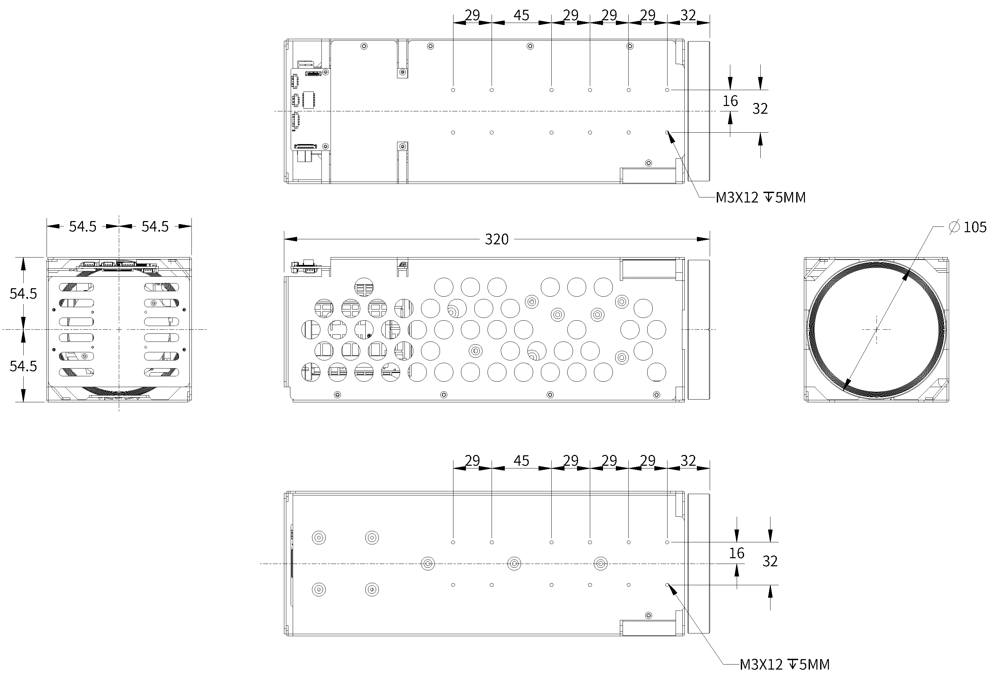
4. Interface Definition
Network Interface
Type | PIN Number | PIN Name | Description
J2_4pin Ethernet Interface | 1 | ETHRX- | Adaptive Ethernet port, Internet RX-
 | 2 | ETHRX+ | Adaptive Ethernet port, Internet RX+
 | 3 | ETHTX- | Adaptive Ethernet port, Internet TX-
 | 4 | ETHTX+ | Adaptive Ethernet port, Internet TX+
J3_6pin Power & UART Interface | 1 | DC_IN | DC12V
 | 2 | GND | GND
 | 3 | RXD1 | TTL Level 3.3V, Pelco Protocol
 | 4 | TXD1 | TTL Level 3.3V, Pelco Protocol
 | 5 | RXD0 | TTL Level 3.3V, Visca Protocol
 | 6 | TXD0 | TTL Level 3.3V, Visca Protocol
J1_5pin Audio Interface | 1 | AUDIO_OUT | Audio Out (Line Out)
 | 2 | GND | GND
 | 3 | AUDIO_IN | Audio In (Line In)
 | 4 | GND | GND
 | 5 | NC | NC
LVDS Interface
Port | Number | PIN Name | Description
J4_30pin LVDS Interface (Similar to SONY 30pin Digital Interface) | 1 | NC | NC
 | 2 | NC
 | 3 | NC
 | 4 | NC
 | 5 | NC
 | 6 | NC
 | 7 | NC
 | 8 | NC
 | 9 | GND | GND
 | 10 | GND
 | 11 | GND
 | 12 | GND
 | 13 | DC_IN | DC power input (DC+7V~+12V)
 | 14 | DC_IN
 | 15 | DC_IN
 | 16 | DC_IN
 | 17 | DC_IN
 | 18 | UART1_TX | TTL level 3.3V, VISCA protocol, the same to TXD0 on J3_6pin Port. But cannot connect at the same time.
 | 19 | UART1_RX | TTL level 3.3V, VISCA protocol, the same to RXD0 on J3_6pin Port. But cannot connect at the same time.
 | 20 | GND | GND
 | 21 | TXOUT0-
 | 22 | TXOUT0+
 | 23 | TXOUT1-
 | 24 | TXOUT1+
 | 25 | TXOUT2-
 | 26 | TXOUT2+
 | 27 | TXOUTCLK-
 | 28 | TXOUTCLK+
 | 29 | TXOUT3-
 | 30 | TXOUT3+

Hangzhou Savgood Technology Co., Ltd.
Rm. 1201, Xincheng Fazhan Building #1, No. 406 Xintiandi Street,
Gongshu District, Hangzhou City, 310015, China
Tel: +86 - (571) 8803 8121
Email: sales@savgood.com
http://www.savgood.com
http://www.savgoodtech.com

*Design and specifications are subject to change without prior notification.
© 2013 Savgood Technology Co., Ltd.

